
Story

Date | 27 October 2026
Team ID | Individual Project
Project Name | EV Market Performance & Insights Dashboard
Maximum Marks | 5 Marks

By using stories in Tableau, you can effectively communicate complex data in a way that is both interactive and engaging, making it easier for the audience to follow along and understand the insights. It’s a tool for data storytelling, allowing you to present insights in a cohesive, engaging way that takes viewers through a logical progression of findings or analyses.
In Tableau, Story is a feature that allows you to create a sequence of dashboards, visualizations, and text to present data insights in a cohesive and narrative-driven way. It's like a slideshow within Tableau that guides the audience through a series of data points, helping them understand key insights, trends, or outcomes of your analysis.

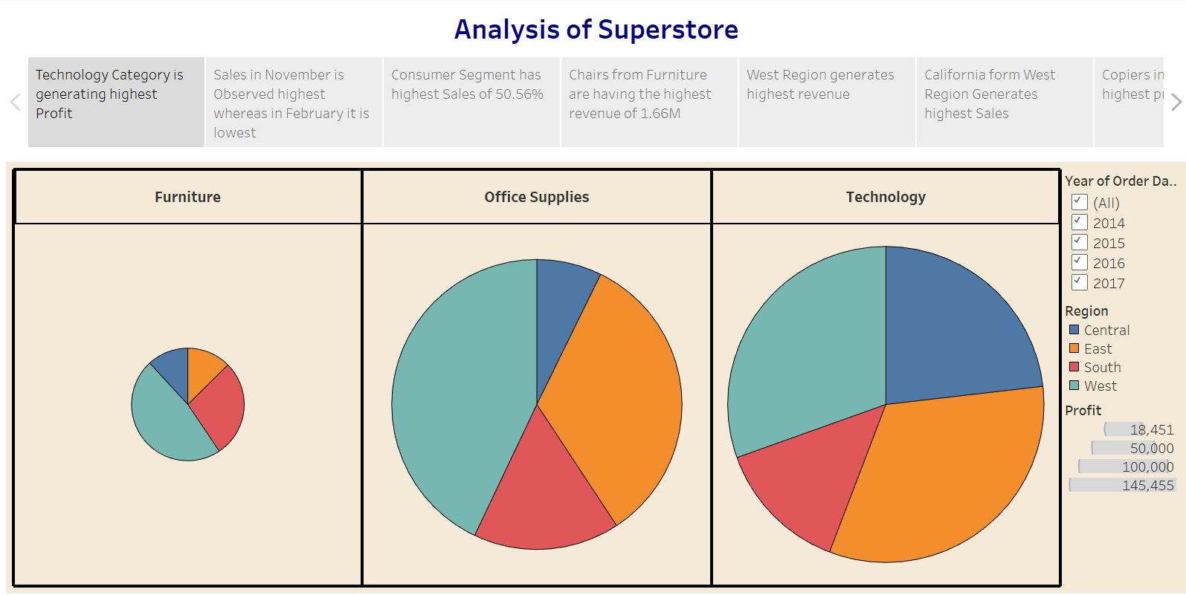

Observations:

Activity 2:
Dashboard link (published Tableau dashboard; separate Story publication not confirmed): https://public.tableau.com/views/EVMarketAnalysisDashboard_17930190186570/Dashboard1

Story Narrative: Start with the dataset overview, then explain the average battery capacity and driving-range KPIs, compare manufacturer counts, review manufacturing-country distribution, and close with limitations and links to the published dashboard and repository. This describes a presentation narrative; a separate Tableau Story object is not confirmed.
Start with the dataset overview, then explain the headline battery-capacity and driving-range metrics. Next compare vehicle records by manufacturer and finish with the manufacturing-country distribution. The story should distinguish descriptive dataset patterns from claims about the whole EV market.
Observations
• The dataset contains approximately 199,999 distinct Vehicle Ids.\n• Average battery capacity is approximately 78.24 kWh.\n• Average driving range is approximately 324.5 km.\n• Manufacturer and country charts show how records are distributed among the available categories.
Published Dashboard Link
https://public.tableau.com/views/EVMarketAnalysisDashboard_17930190186570/Dashboard1

